Hampton Academy Supply List
K-2 Preschool

✔ P.E Kits (to be purchased at school)
✔ School Insurance (Colina) $20.00
✔ School Jacket
Supplies
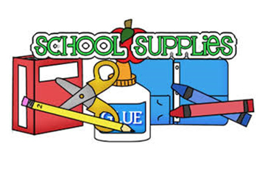
- 2pk Computer Paper
- Self Adhesive Velcro Dots
- 1 Pk Laminating Sheets
- 1 Pk Construction Paper
- 2 Paperback Folders
- 1 Clear Document Folder with snap
- 1 Composition Book
- Index Cards
- Jumbo Pencils
- Pencil Case
- Jumbo Eraser
- Sharpener
- Jumbo Crayons
- Coloring Book
- Waterproof Reusable Kid Apron
- Washable Paint and Paint Brushes
- Glue (Bottle and Stick)
- Safety Scissors
- Dry Erase Markers
- Dry Erase Mini Board
- Hand Sanitizer & Hand Soap
- Disinfection Wipes and Spray
- Kinder Mat/Sleeping Bag with Blanket/Towel
- Tablet
*Always keep a change of clothes and baby wipes in school bag. *Please note that supplies may need to be replenished during the school year.

