Hampton Academy Supply List
K-3 Preschool

✔ P.E Kits (to be purchased at school)
✔ School Insurance (Colina) $20.00
✔ School Jacket
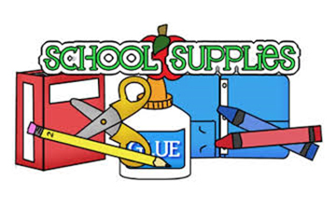
Supplies
- 2pk Computer Paper
- Self Adhesive Velcro Dots
- 1 Pk Laminating Sheets
- 1 Pk Construction Paper
- Jumbo Pencils
- Pencil Case
- 3 Jumbo Erasers
- Sharpener
- 1 Pk of Washable Markers
- Jumbo Crayons
- Coloring Book
- Art Apron
- Washable Paint
- Bottle Glue
- Safety Scissors
- Dry Erase Markers
- Hand Sanitizer & Hand Soap
- Disinfection Wipes and Spray
- Waterproof Reusable Kid Apron
- Eating Bibs
- Labelled Utensils
- Kinder Mat/Sleeping Bag with Blanket/Towel
- Change of Clothes (Labelled)
- Pull ups and Wipes
- Tablet and Headphones (Term 2)
*All items are due the first week of school. Please label your child’s supplies.
* Supplies may need to be replenished during the school year.
● Please purchase small backpack and small lunch bag.
● Crocs are preferred footwear with full uniform on Monday’s and Wednesday’s and tennis on Tuesday’s and Thursday’s.

