Hampton Academy Supply List
Self-Contained

✔ P.E Kits (to be purchased at school)
✔ School Insurance (Colina) $20.00
✔ School Jacket
Supplies
- 2 Packs #2 Pencils
- 1 pack Jumbo Crayons (8 count)
- 1 pack Regular Size Crayons (16 count)
- 1 pack Dry Erase Markers w/board eraser (black and coloured)
- Dry Erase Board (personal size)
- Washable Markers
- Washable Paint and Paint Brushes
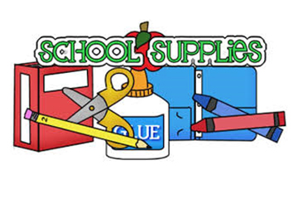
- 3 Jumbo Erasers
- Pencil Box
- Pencil Sharpener and Crayon Sharpener
- Bottle glue
- 1 pack glue sticks
- 2 packs Self-Adhesive Velcro Dots
- 1 pack laminating sheets (5mil)
- 1 Scissors (blunt edge)
- Index Cards (coloured and white)
- Art Apron
- (2) 3inch White Ring Binder
- 2 packs white Printing Paper
- 4 Composition Books (K-2) skill appropriate lines
- Headphones
- Tablet
- Big bottle Hand Sanitizer
- Big bottle Hand Soap
- 1 pack Lysol Spray and 1 pack Lysol Wipes
- Disposable Wipes

*Textbooks and Workbooks will be covered under Material Fees.

